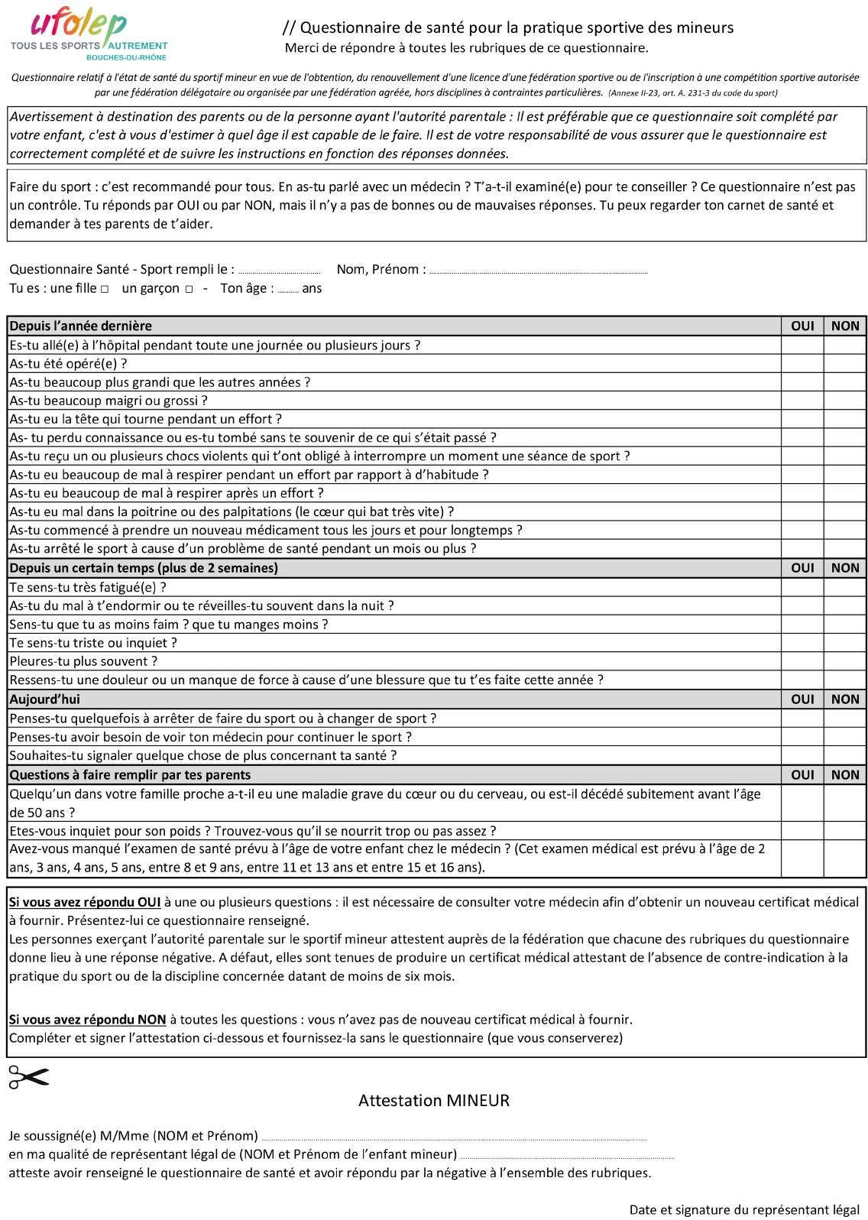2023 - 2024

............................................................................................................................................................................................................................................................................